Course Title: Agentic AI

Assignment Title: AI Email Assistant Workflow

Submitted To: Miss Muskan Atiq

Submitted By: Fatima Hussain

Student ID: AGI-918851

Submission Date: November 2, 2026

Gmail Trigger:

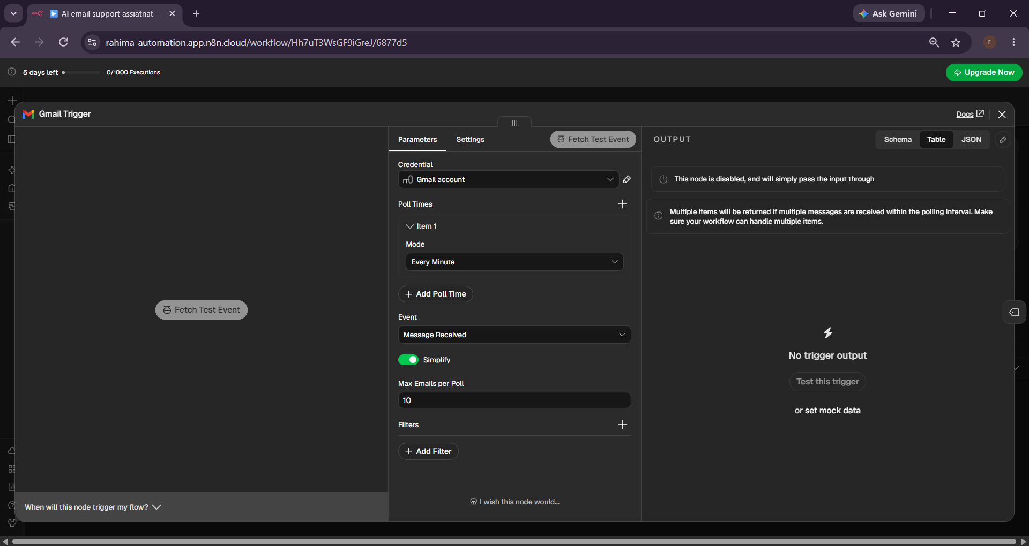

Text Classifier:

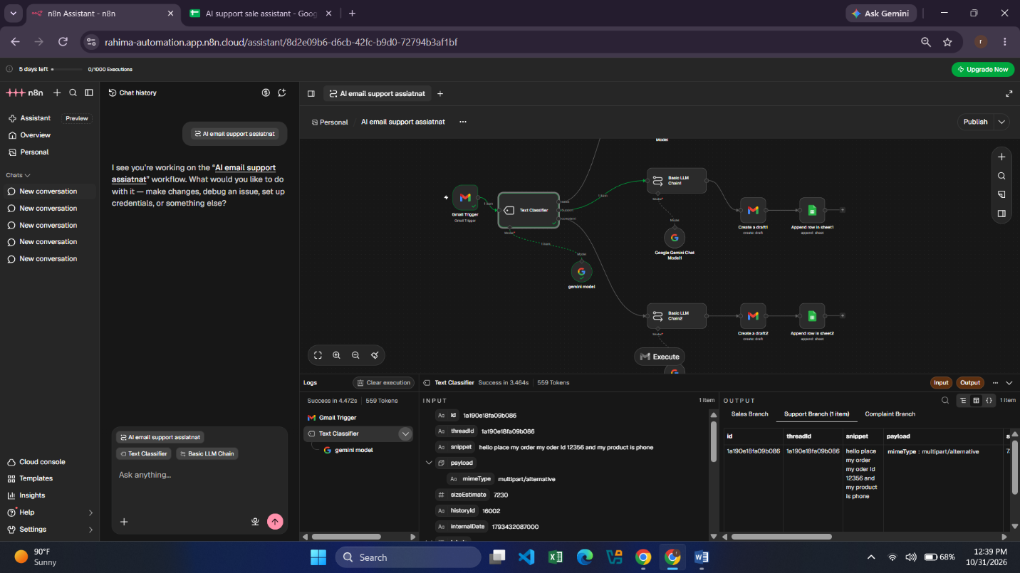

Basic LLM Chain For Sales:

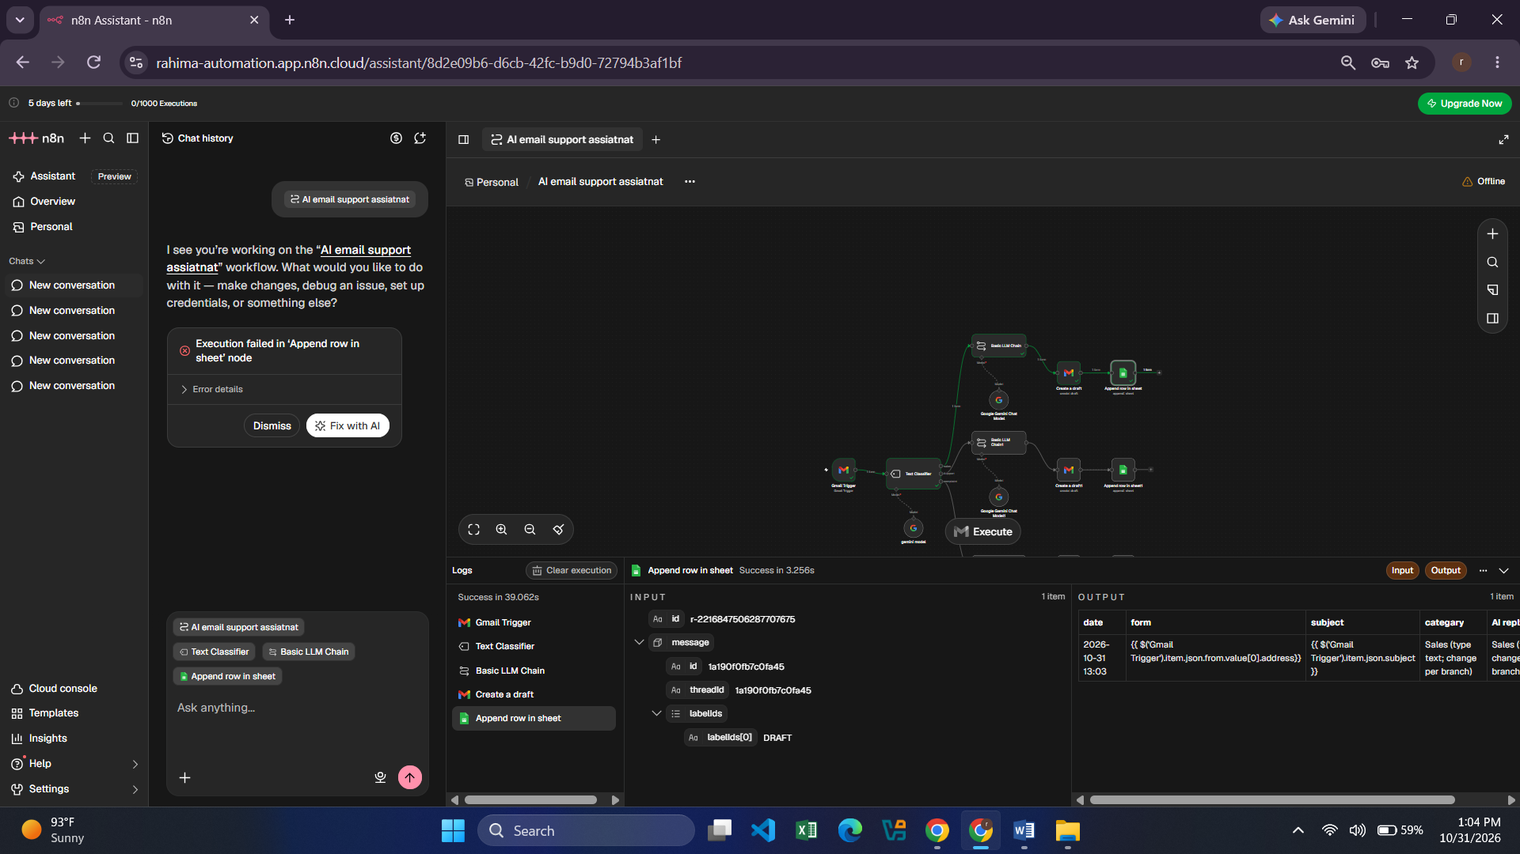

Sales Google Sheet DataBase:

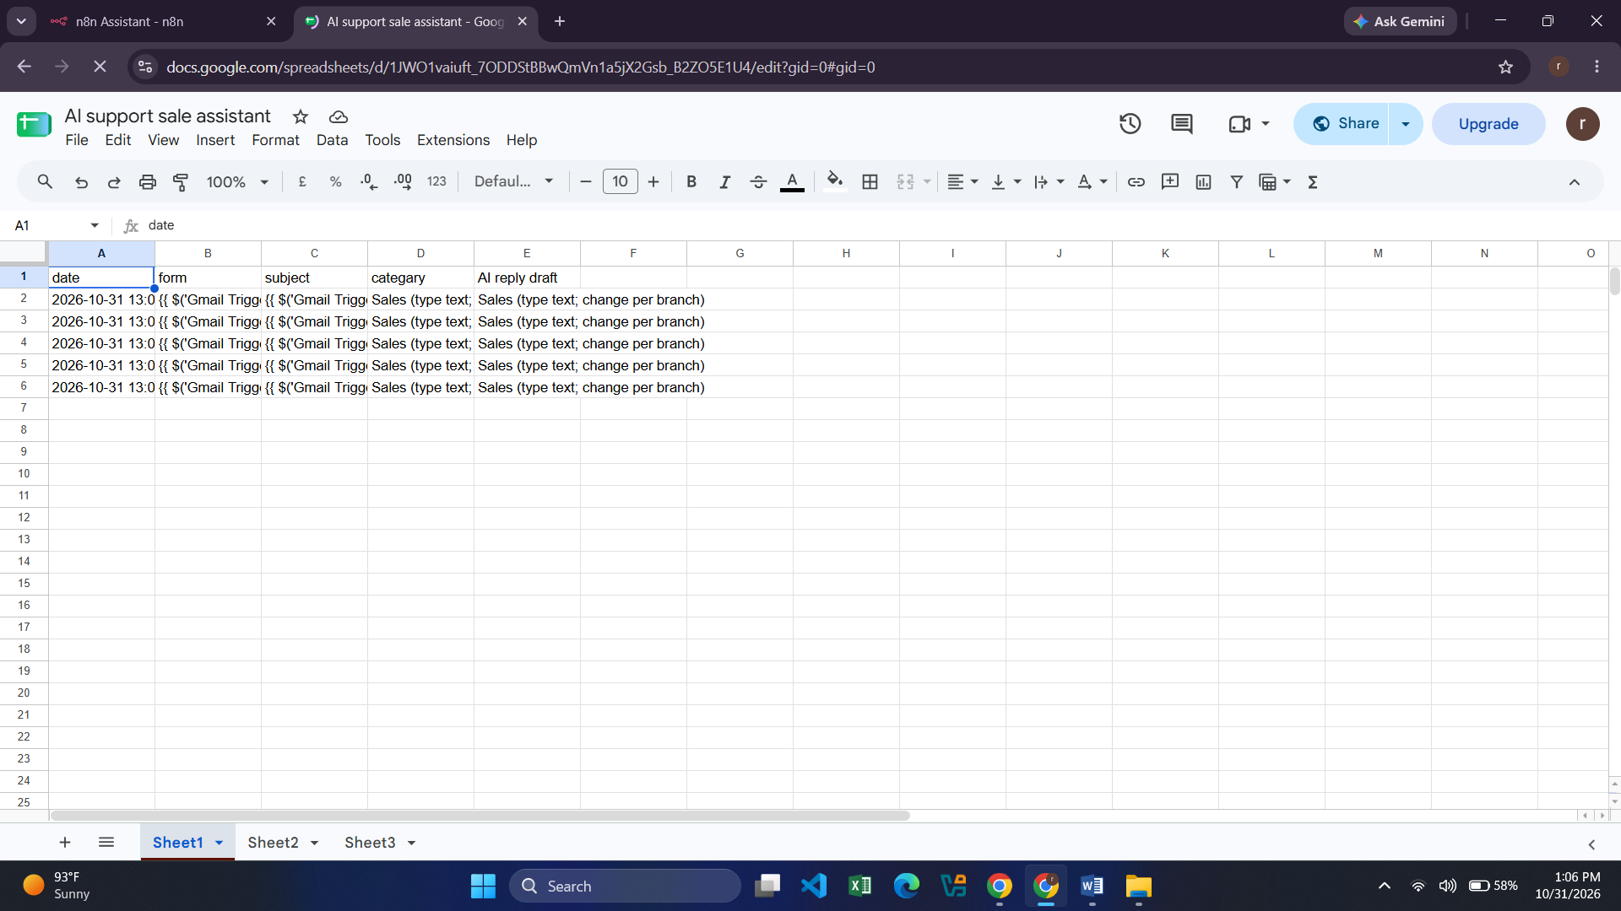

Basic LLM Chain For Support:

Support Google Sheet DataBase:

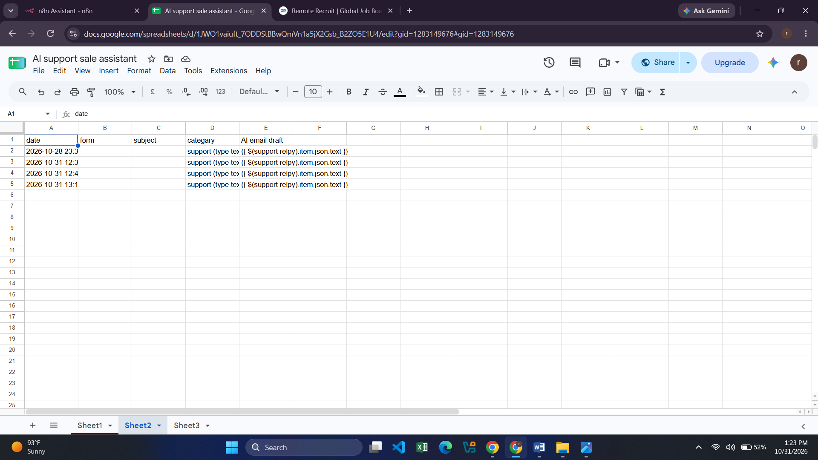

Basic LLM Chain For Complaint:

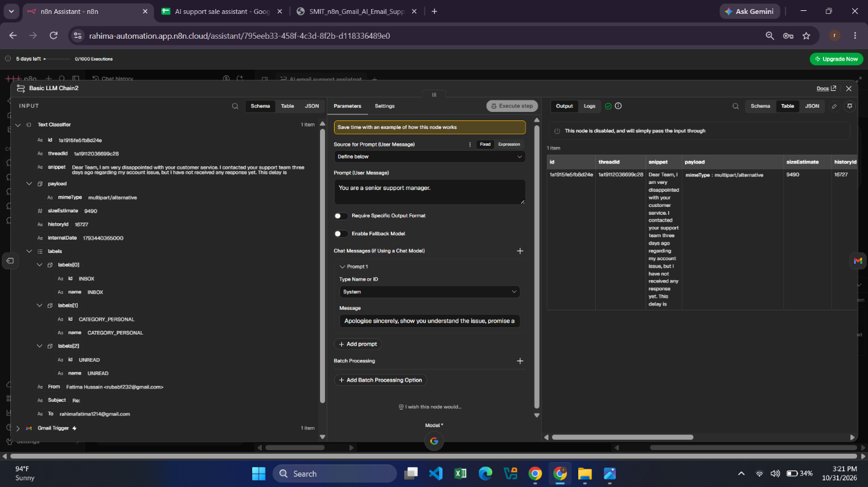

Complaint Google Sheet DataBase:

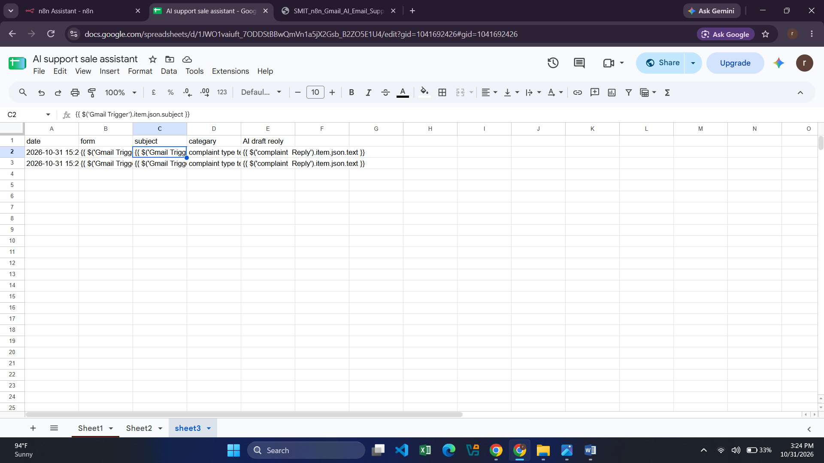 Final result:
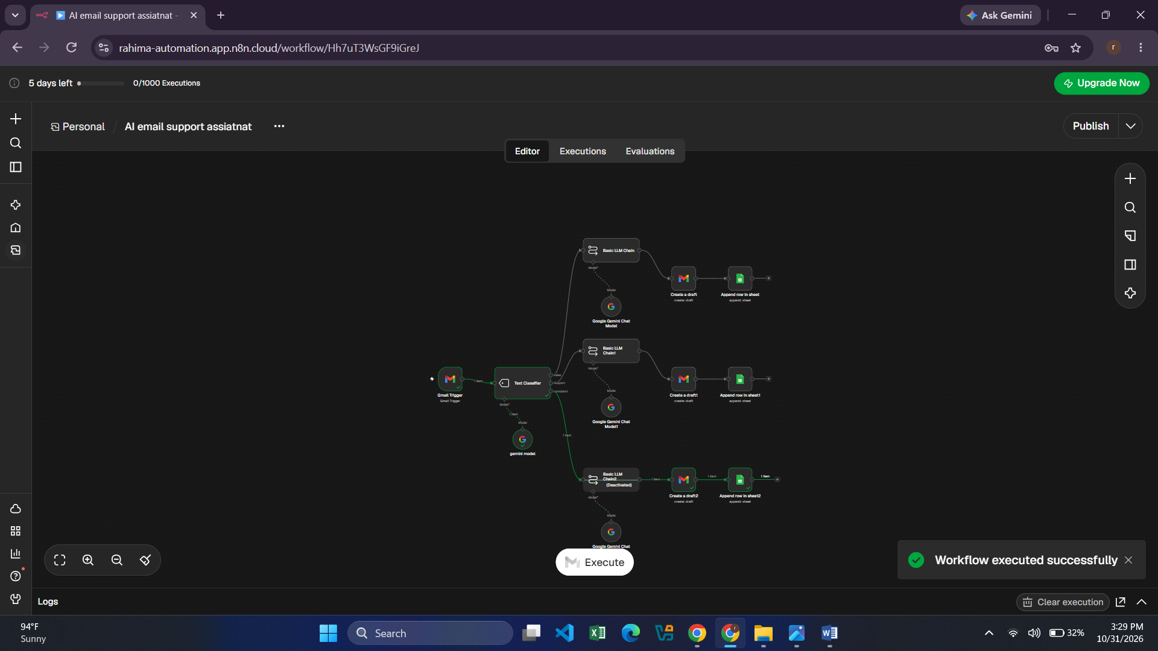

THE END

